**Component Diagram**

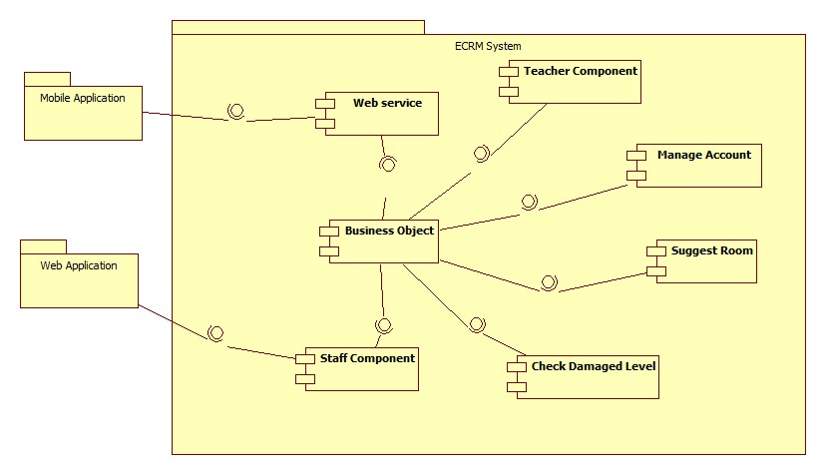

|  |  |
| --- | --- |
| Component Dictionary: Describes components | |
| Web Application | Web application package: View, Controller. |
| Mobile Application | Mobile application package. |
| Web Service | Include all web API controllers of the system. Include all web API controllers of the system |
| Staff Component | Component to handle staff activities in the system |
| Teacher Component | Component to handle teacher activities in the system |
| Manage Account | Business logic for manage account processing. |
| Business Objects | Handle business operations for every component. |
| Suggest Room | Business logic for suggest room processing. |
| Check Damaged Level | Business logic for checking damaged level processing. |

**Entity Relationship Diagram**

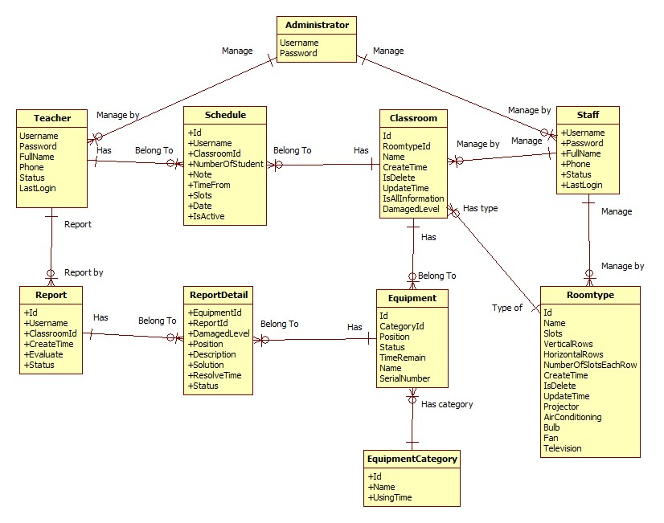

|  |  |
| --- | --- |
| Entity Data Dictionary: Describes contents of all entities | |
| Administrator | Contain information of administrator. |
| Staff | Contain information of staff. |
| Teacher | Contain information of teacher.Include all web API controllers of the system |
| Schedule | Contain information of schedule. |
| Classroom | Contain information of classroom. |
| Roomtype | Contain information of room type. |
| Equipment | Contain information of equipment. |
| EquipmentCatregory | Contain information of equipment category. |
| Report | Contain information of report. |
| ReportDetail | Contain information of report detail. |